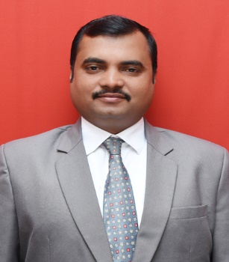
RESUME

DR. KOTWAL SACHIN VALMIK

Residential Address: Flat No.B804, Blessing Society, Bhavadi Road , Wagholi, Tal- Haveli, Dist.- Pune. Pin-412207 (Maharashtra). India.
Permanent Address A/P- Ashtapur, Tal- Haveli, Dist.- Pune. Pin-412207 (Maharashtra). India
Mobile No: 9595357070
Email-Id: svk.sucop@gmail.com, sachin8400@gmail.com

Objective:

I seek challenging opportunities where I can fully use my skills and education for the success of the students and organization using both traditional and modern approaches which ultimately a highly rewarding career for personal growth.

Academic Profile:

Degree | College | University | Passing  Year | Percentage/  Division
Ph.D. | JJT University,Rajasthan. | JJT University, Rajasthan | 2022 | --
M. Pharm. | PES College of pharmacy, Bangalore. | RGUHS, Karnataka. | 2007 | First
B. Pharm. | P.D.E.S’s Seth Govind  Raghunath Sable College  of Pharmacy, Saswad. | Savitribai Phule Pune University, Pune, Maharashtra | 2005 | First

Academic, Industrial & Research Experience:

- Principal , PDEAs S.U.College of Pharmacy ,Kharadi, Pune-411014

- Production Officer Cipla. Ltd, Kurkumb Pune .

Total experience in years
- Teaching: 14 years
- Research: 01 Year

Paper Publications: 12

Paper Presentations: 11

Seminars/Workshops/ Conferences attended: 30
Personal Details:

Name: Dr. Kotwal Sachin Valmik
Address: Ashtapur, Tal- Haveli, Dist.- Pin-412207 (Maharashtra).India

Mobile Number: 9595357070
E-mail: svk.sucop@gmail.com
Date of Birth :04th April 1984
Age : 37 Years
Marital Status :Married
Gender :Male
Nationality: Indian
Languages Known: English, Marathi and Hindi

Declaration:
I hereby declare that the information furnished above is true to the best of my knowledge.
Date:

Place: Pune (Dr. Kotwal Sachin Valmik)

